1. **Control algorithm for dosing oxygen in sewers**

* 1. **Background**

Oxygen is one of the most used chemicals for the control of sulfide production. Oxygen relies on sulfide oxidation, both chemical and biological, as the mechanism for H2S control.

|  |
| --- |
| Further information can be obtained as follows:   * Effects of oxygen dosing:   + **Paper:** *Gutierrez, O., Mohanakrishnan, J., Sharma, K.R., Meyer, R.L., Keller, J. and Yuan, Z. (2008) Evaluation of oxygen injection as a means of controlling sulfide production in a sewer system. Water Research 42(17), 4549-4561.* |

* 1. **Control Strategy**
     1. **Dosing Location**

A suitable location for oxygen dosing (*x*) can be theoretically determined from Equation 1.

 (1)

Where *D* is the pipe diameter (m), *L* is the pipe length (m), *rB* the sulfide production rate of the biofilm (gS/m2▪d), *rB,ox* the biological sulfide oxidation rate of the biofilm (gS/m2▪d), *rC,ox* the volumetric chemical sulfide oxidation rate (gS/m2▪d), *TDS0* the total dissolved sulfide at the beginning of the rising main (g/m3), *TDSf* the total dissolved sulfide at the end of the rising main (g/m3) and QL is the sewage flow (m3/d).

* + 1. **Dosing rate**

Assuming an oxygen dosing station located in a downstream section, close to the rising main discharge point, oxygen dosage for an optimised dosing depend on two factors:

* The amount of sulfide produced upstream that needs to be oxidised
* The oxygen that will be consumed by heterotrophic bacteria during the transport time between the dosing location and the discharge/control point.
  + - 1. *Sulfide produced upstream*

Sulfide concentration at the dosing location can be measured using a S::CAN UV/VIS spectrometer. If online measurement is unavailable, typical sulfide profiles can be estimated based on HRT as illustrated in Figure 1.

HRT_TDS.TIF

Figure 1. Total dissolved sulfide vs. hydraulic retention time.

The amount of oxygen required for sulfide oxidation to sulfite is 1.5 gO2/gS-S2, whereas 2 gO2/gS-S2 are required to convert sulfide to sulfate according to equation 2 and 3.

2. (2)

(3)

* + - 1. *Heterotrophic oxygen consumption downstream*

Oxygen consumption rate by heterotrophic bacteria can be modelled using a Monod kinetic according to the following equation:

 (3)

Where *rarea* is heterotrophic oxygen consumption rate of the biofilm (mg N/L); *rarea,max* is the maximum oxygen consumption rate of the biofilm;  is the oxygen concentration in the boundary layer of biofilm (mg N/L) and  is the half-saturation substrate limitation constant for oxygen in the biofilm.

For a given pipe diameter and retention time, the amount of oxygen to be dosed to reach the desired concentration at the discharge point can be estimated by equation 3 using a Newton iteration method.

Due to the intermittent operation pattern of sewer pumping stations, the effects of quiescent periods on oxygen consumption rate is also taken into consideration (Figure 2).

quiescent.TIF

Figure 2. Pumping profile, HRT downstream and activity corrected by quiescent conditions.

* + - 1. *Future flow prediction*

The heterotrophic oxygen consumption depends on the time the wastewater will be spend in the last section of the pipe. This can be estimated using typical HRT profiles (simple). Otherwise, future flow can be predicted based on ARMA models.

* + - 1. *Feedback Loop*

A feedback loop could be implemented to adjust the dosing based on weekly average of dissolved oxygen concentration at the discharge point. This would require additional instrumentation to measure dissolved oxygen online.

* + 1. **Control scheme**

The control algorithm for the optimised dosing of oxygen is composed of a feedforward and a feedback loop. The feedforward loop will predict the amount of oxygen required to oxidise sulfide produced upstream the dosing location and ensure aerobic conditions of sewage until its discharge. In addition, the feedback loop can adjust the dosing based on the overall performance. A scheme of the control algorithm is depicted in Figure 3.

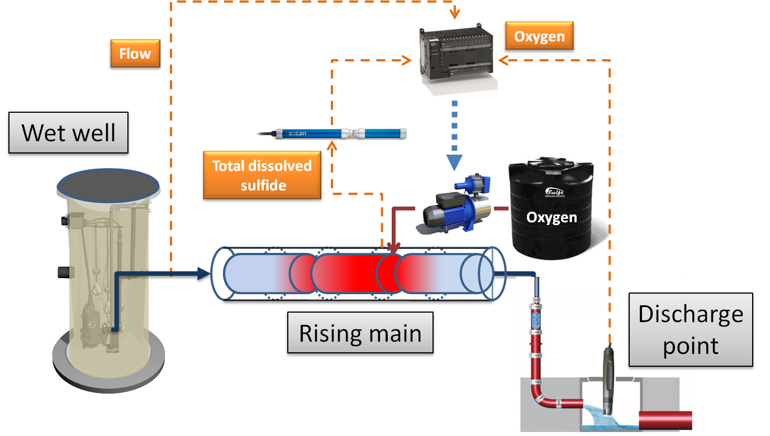

Figure 3. Control algorithm scheme for oxygen dosing.

* 1. **Case studies**

Oxygen dosing in the Cowie Creek sewer system (Barwon water) in Geelong, Australia